  L1 FA24

Q1:

Software Requirements Specification

for

Dao Tao FPT (DTFPT)

Version 1.0 approved

Prepared by

Kyuumei Neko - HExxxxxx

FU Hoa Lac

Monday, 11/11/2024

Q2:

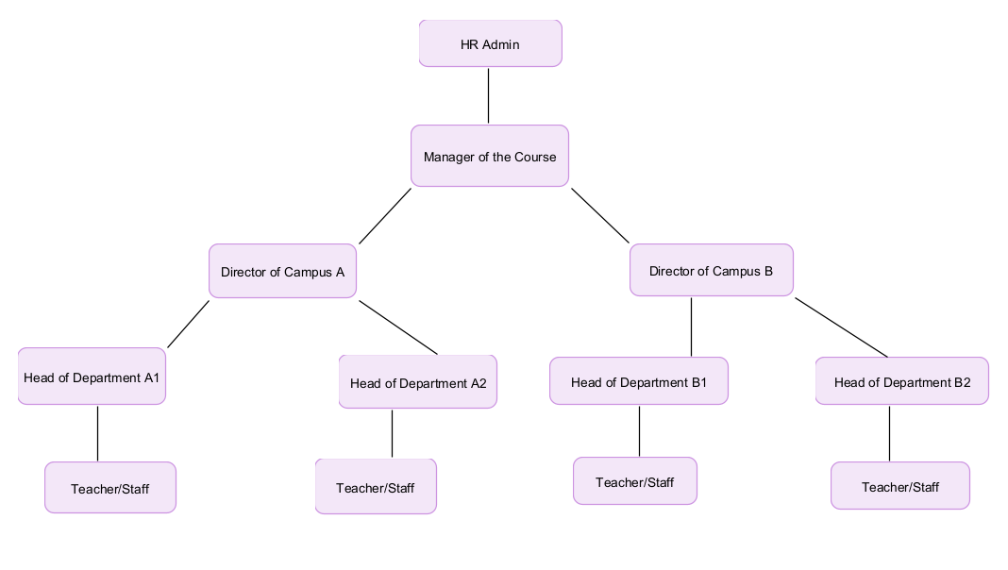

I think that Teacher or Staff are likely to have the largest number, as they represent the lower-level roles accessible to multiple users across campuses and departments.

Q3:

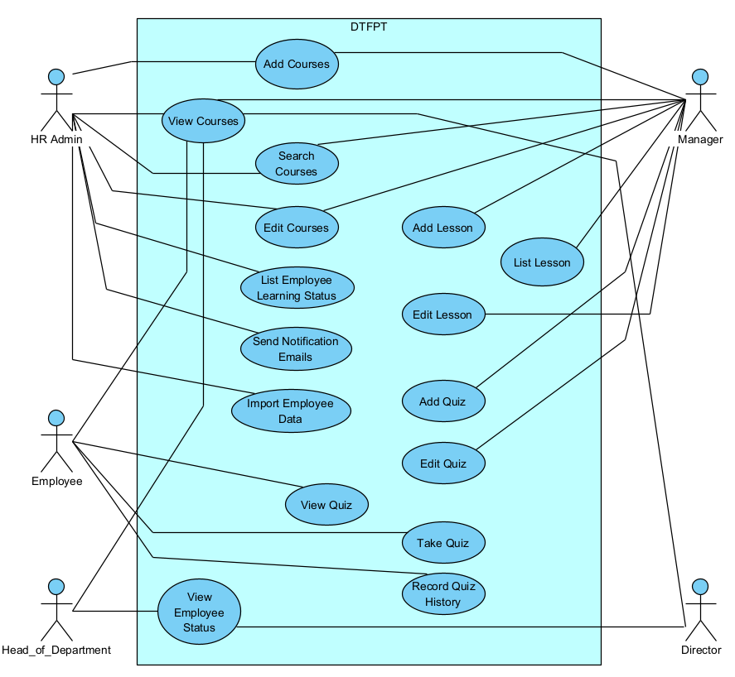

Q4:

|  |  |  |  |
| --- | --- | --- | --- |
| UC ID and Name: | UC – 1 Add Lesson | | |
| Created By: | Kyuumei Neko | Date Created: | 11/11/2024 |
| Primary Actor: | Course Manager | Secondary Actors: | Teacher |
| Trigger: | 1. The primary actor decides to add a new lesson to an existing course to provide additional training materials. 2. A new module or topic in the course requires an additional lesson to be added. | | |
| Description: | As a Course Manager, adds a new lesson to a course in the DTFPT system. The lesson can include a title, content, and other materials as needed for the training course. | | |
| Preconditions: | 1. The user (Course Manager or Teacher) is logged in to the DTFPT system. 2. The user has permission to add lessons to the course. 3. The course to which the lesson will be added already exists. | | |
| Post conditions: | 1. A new lesson is successfully created and added to the course. 2. The lesson is available for viewing and editing within the course. | | |
| Normal Flow: | 1. The primary actor (Course Manager) navigates to the course page in the DTFPT system. 2. The primary actor selects the option to "Add Lesson." 3. The system displays a form for adding lesson details, including fields for lesson title, description, and content. 4. The primary actor enters the lesson details. 5. The primary actor submits the form. 6. The system validates the entered information. 7. The system saves the lesson to the database and links it to the selected course. 8. The system confirms that the lesson has been added successfully. | | |
| Alternative Flows: | * 1. Missing Information  1. If the primary actor omits required fields (e.g., lesson title), the system displays an error message. 2. The primary actor provides the missing information and resubmits the form. | | |
| Exceptions: | * 1. Duplicate Lesson Title: If the primary actor enters a lesson title that already exists within the same course, the system displays an error message indicating that the lesson title must be unique. | | |
| Priority: | High | | |
| Frequency of Use: | High | | |
| Business Rules: | 1. Only users with the "Course Manager" or "Teacher" roles are allowed to add lessons to a course. 2. Each lesson must have a unique title within a course. 3. The lesson content must comply with FPT Corporation’s training guidelines and policies. | | |
| Other Information: | N/A | | |
| Assumptions: | 1. The DTFPT system is stable and capable of handling multiple requests for adding lessons simultaneously without performance degradation. 2. Course Managers and Teachers have received prior training on how to use the lesson creation functionality in the system. 3. Lesson content, including multimedia files (if applicable), will be uploaded within system-defined size limits. 4. The system includes validation checks for required fields to prevent incomplete lesson entries. | | |

**Q5:**

1. Performance requirements: The DTFPT system must be able to handle at least 1,000 concurrent requests from users at the same time, especially in the functions of viewing courses, adding lessons and taking tests. This requirement ensures that the system meets the usage requirements of all FPT Corporation employees and companies. The number of 1,000 is determined based on the number of employees who can access the system during peak working hours.

2. Availability requirements: The DTFPT system must ensure a minimum level of availability of 99.5% during stable operation time (24/7) to ensure that employees can access courses and tests at all times. The rate of 99.5% is determined based on the industry standard for online training systems, allowing no more than 3.65 days of downtime per year. This is to ensure the continuity of internal training for all FPT Corporation employees.